WeRateDogs!: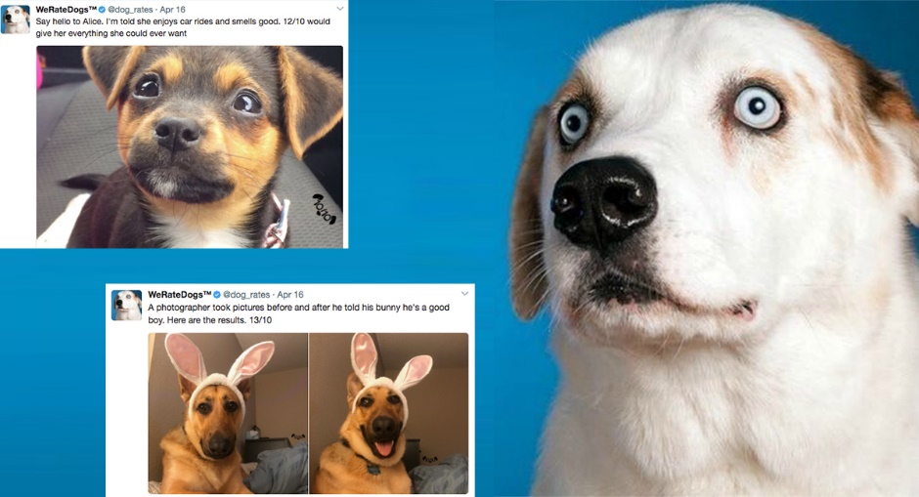

At WeRateDogs you can send your pet pics to get rated and retweeted! I wanted to do a study of this site to see if the comments they make lead to more favorites and retweets from Users. So, I went out and grabbed the counts of retweets and favorites for each of these original pics and took a bit more data provided by Udacity to look a bit further and see how much this account can boost a tweet.

To get that Twitter data I had to query Twitter’s API, Tweepy. Overall it is fair to say that really any dog pic is going to get a high rating from this type of service. However, let’s look at their ratings overall compared to the number of retweets and favorites. Then, we will look at a categorical aspect of the WeRateDogs program and how it works.

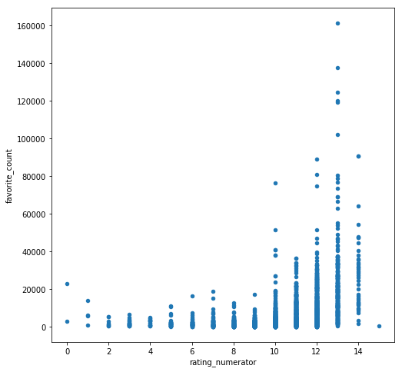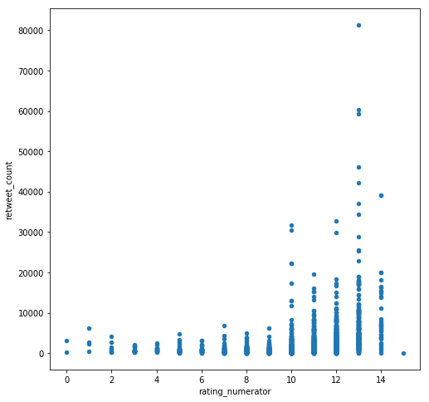

On the left you can see the favorite’s counts rising as the rating from WeRateDogs rises as well, the same trend you can see on the right in the number of retweets. That’s to be expected I suppose! It might be interesting to look at the counts in each of these categories and their scores vs whether or not the WeRateDogs service predicted that the picture was of a dog, not a dog, or some mixed prediction based upon the three dog breed and yes/no prediction of the picture being a dog or not. The dog distinction I made is when all three predictions are dog. The not a dog is just the opposite and our mixed prediction is.. you guessed it… when one or two of the predictions aren’t consistent with the others. Check it out:

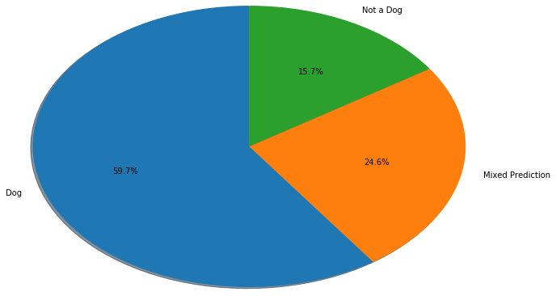

Ok cool so right at 75% were completely consistent in the predictions. I would be interested to see how accurate that is if I took the time to look through and match every picture. There is a lot more to learn from this project!